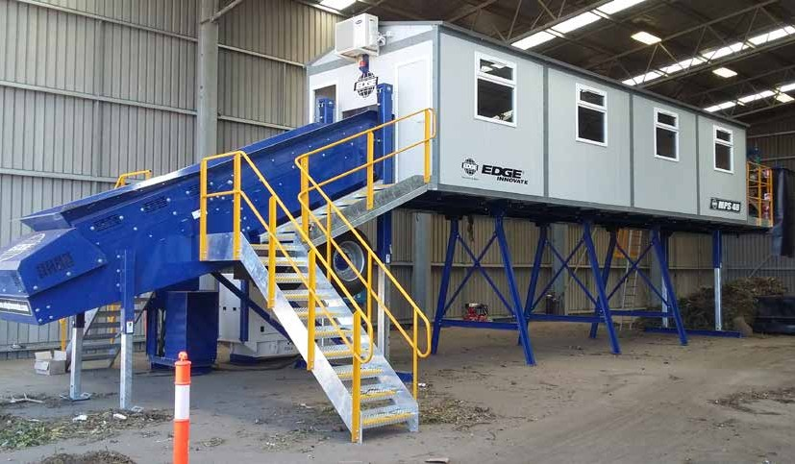

EDGE MPS48 SERIES

designengineeringinnovation

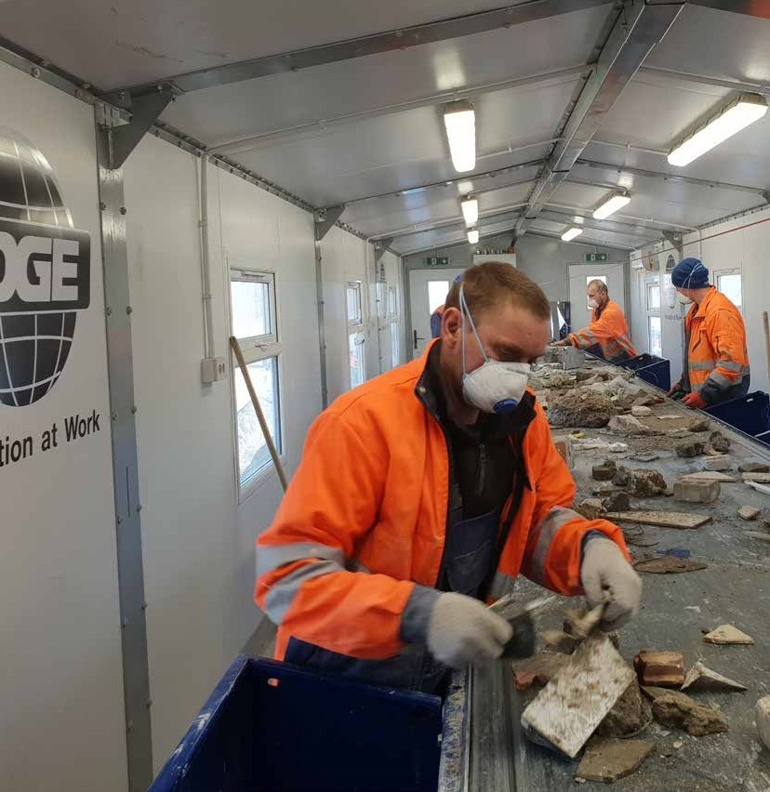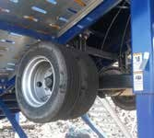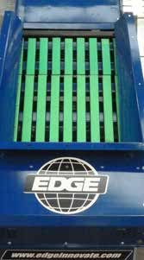MOBILE. MODULAR. PICKING STATION.

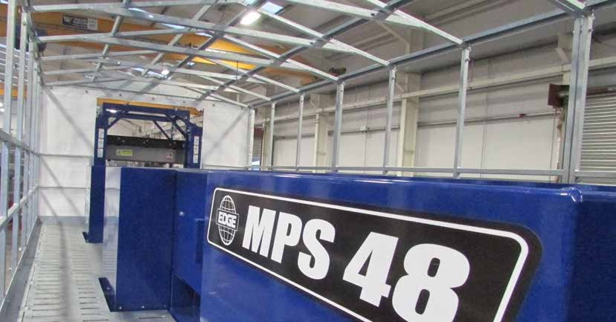PRODUCT

HIGHLIGHTS

KEY HIGHLIGHTS THE ONLY FULLY MODULAR PICKING

Choose from 1-16 Picking Modules.
Add or remove bays at ease to fit any situation.

Can be fed by any primary, secondary Crusher, Screener or Trommel.

Can meet the customer demands by not limiting the number of bays they can choose.

Heavy duty input section with impact bars and feedboot with additional support legs.

Innovative “Sea-Can friendly”
design for global export.
STATION ON THE MARKET...
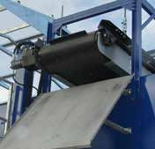
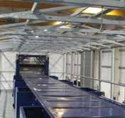
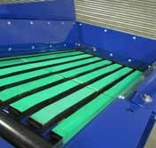
The EDGE Modular Picking Station is the most robust, durable, long lasting and user-friendly Picking Station on the market today. It boasts a range of features that makes it very popular with Transfer Stations, Skip Hire companies, Waste handling Depots etc.
The MPS has been uniquely designed so that Picking Bays can easily be added or removed in line with changing customer requirements. This unique feature enhances the versatile nature of the MPS meaning it can fit pretty much any scenario!

Designed and built with a range of applications in mind, the MPS48 can

Flexible heights to suit a range
of skips/ bins below platform.
be fitted with a multitude of options such as roofing, lighting, insulated air conditioned enclosures with windows and heating, air Separators, over-band

magnets, etc.
Essentially the Edge Picking Station can be tailored to your needs. The EDGE

Belt widths from 36” (900mm) -
48” (1200mm) available.
Design Team has engineered the MPS48 for “sea-can friendly” transportation meaning it can be shipped anywhere in the world.

DESIGN]FEATURES

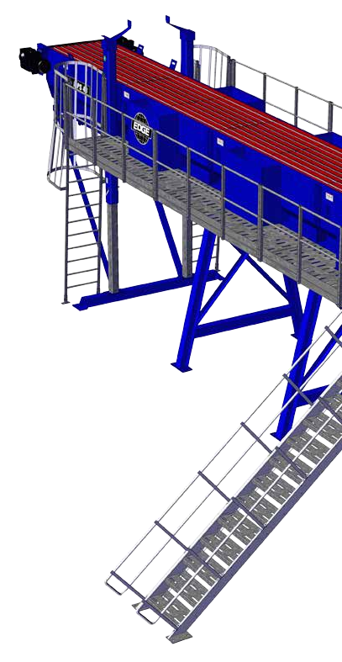EDGE Innovate have worked tirelessly to ensure our products are of the highest quality. We only ever use parts and products that have been developed, tested and proven to provide optimal performance and reduce operating and maintenance costs. Every part is vital for uptime and performance.
6
5
4

APPLICATIONS
Construction and Demolition waste
Municipal Solid Waste
Domestic and Household Waste
Wood waste

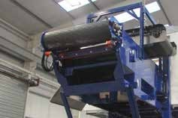
6
CONVEYOR HEAD SECTION

- Various options are available for operators including two different power-source types with the option of hydraulic or electric direct drive.
- An Over-band magnet to reclaim ferrous metals along with walkway access are also available.

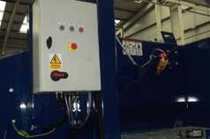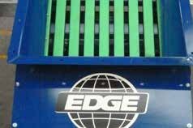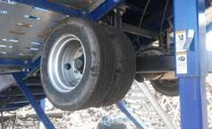
1
CONTROL PANEL
2
FEEDBOOT
3
BRAKING AXLE

- Control panel consisting of a XPS emergency stop relay, pre-start siren circuit, test/off/manual keyswitch, isolator switch, speed adjustment and a hour run counter display
- Supplied along with associated test certificate and control panel diagrams.
- Heavy duty input section with impact bars and a feedboot capacity of 1.3m³ (1.7yds).
- 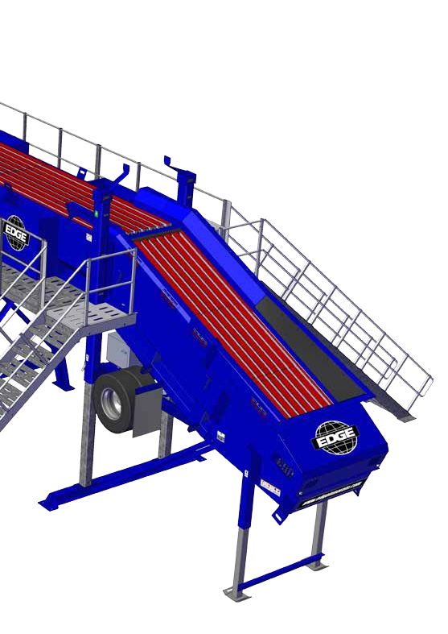A 1200mm (48”) wide belt provides an even spread of material allowing for a better presentation of commodities to the pickers.
- Recommended for those
operators with multiple sites.
- Consisting of tandem wheels and air brakes, the MPS48 can be transported from site to site.
- Option of a diesel/hydraulic power-source can be fitted to axle chassis.
- Impact bars absorb the impact of the feed material prolonging the lifetime of the belt.

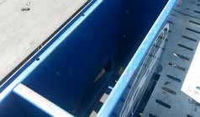1
4
MODULAR PICKING BAY

2

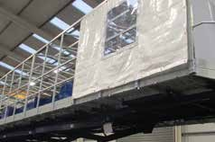
- The modular design allows for customers to increase bay and picking capacity as and when needs require.
- Built to last, the MPS48 is constructed using heavy duty side plate with a side frame depth of 1050mm (42”).
5
WALKWAYS

3
- Design to meet all safety legislation, we offer various walkway options and configurations
- Ladder access and head section platforms are also available

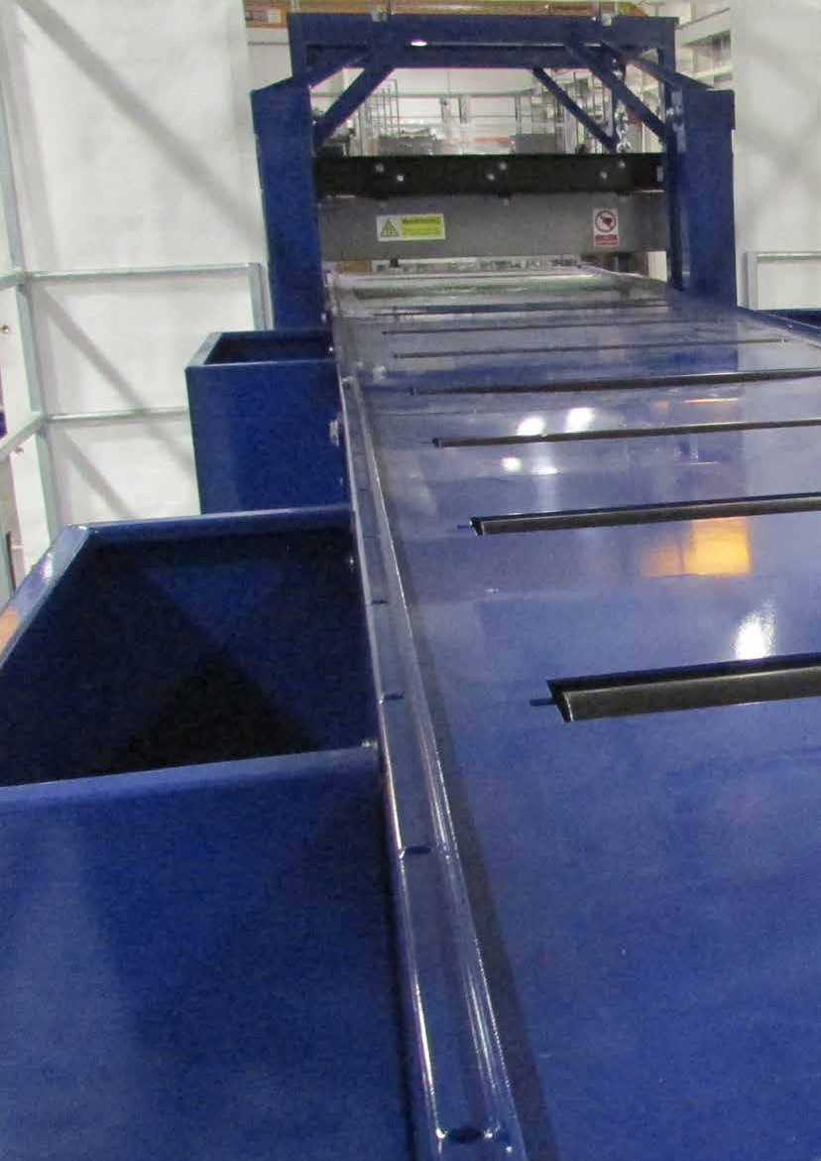

ADDITIONAL]OPTIONS

Diesel Hydraulic
Direct Electric
Diesel Genset
8HP Engine

CAT2.2 Deisel/Hydraulic powerunit with a fuel consumption of 9.48ltr/ Hr (2.5USG)

Various direct electric drive motors including single or twin

Provides operators with two running options. Grid electric power or diesel generator

8HP engine option available to raise and lower hydraulic jacklegs to desired height

Electric Panel
Full Length Impact Bars
Hydraulic Jack Legs
Over-Band Magnet

Electric panel available with speed adjustment, emergency stop relay and pre-start siren circuit
Recommended for heavy applications such as aggregates and C&D waste
Available with or without diesel engine to enable quick transition from transport to operational mode.
Head section over-band magnet with stainless steel chute to extract ferrous metal

Air Knife
Enclosed Cabin
Roof Frame
Air Brakes

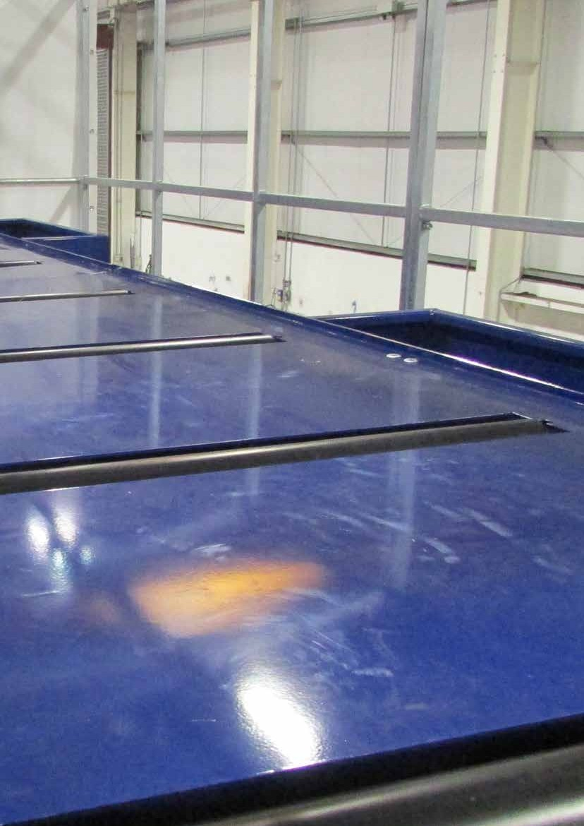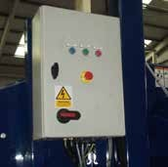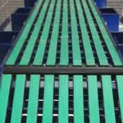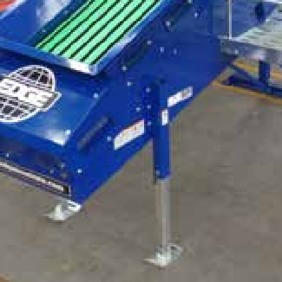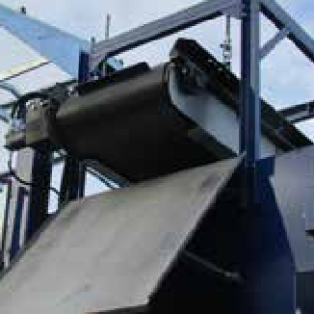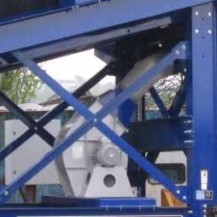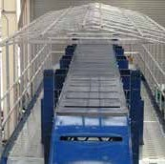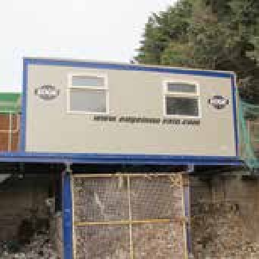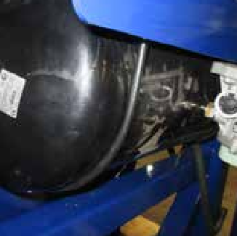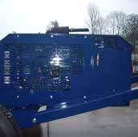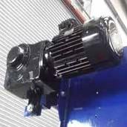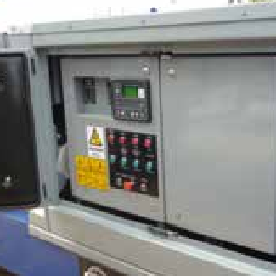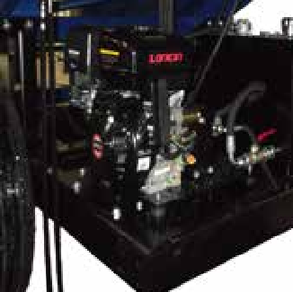Air knife consisting of a 18.5KW motor. A lights cage is recommended along with this option
Enclosed cabin with lights, windows, heat or or air conditioning available
Roof module allowing for single skin cladding to be attached
Air brakes recommended for operators with multiple sites

Machine | Conveyor Length | Belt Width | Picking Bins | Tonnage | Discharge Height
3 Bay | 16.3m (53’5”) | 1200mm (48”) | 6 | Up to 100 TPH (110USG) | 2.9m (9’5”)
4 Bay | 23.4m (59’9”) | 1200mm (48”) | 8 | Up to 100 TPH (110USG) | 2.9m (9’5”)

TRANSPORT DIMENSIONS

Machine | *Weight | Height | Length | Width
3 Bay | 11 Tonnes (12UST) | 2.8m (9’2”) | 15.3m (50’5”) | 2.3m (7’7”)
4 Bay | 12 Tonnes (13.2UST) | 3.3m (10’10”) | 18.2m (59’9”) | 2.3m (7’7”)

OPERATING DIMENSIONS

Machine
Height Length

Width

- Bay

Bay
2.8m (9’2”)
2.9m (9’2”)
16.3m (53’5”)
23.4m (66’10”)
3.3m (10’10”)
3.3m (10’10”)

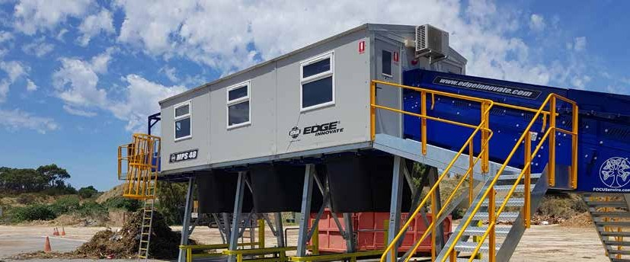
TECHNICAL SPECIFICATIONS

MPS48 3 BAY OPERATIONAL DIMENSIONS
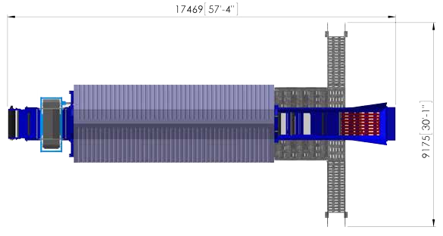
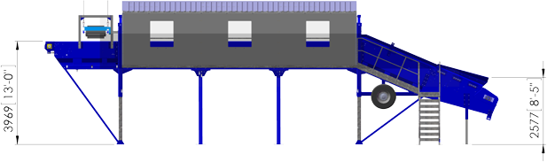

MPS48 4 BAY OPERATIONAL DIMENSIONS
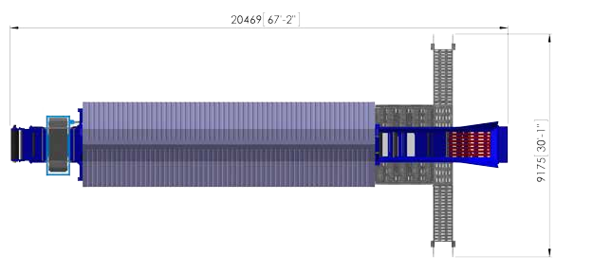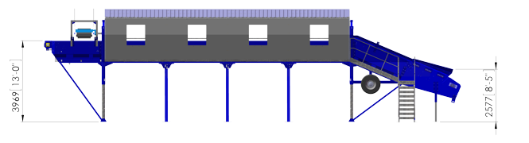

WE]ARE]HERE]WHEN]IT]MATTERS]MOST
Customer for life

PRODUCT AND TECHNICAL SUPPORT

With our ethos of “Innovation at Work”, EDGE not only persist in pushing the boundaries of design and manufacturing to produce hard working, quality machinery, we also bring that same ethos to our aftersales service in order to bring real benefits to customers right across the world. At EDGE we like to see the sales transaction as the start of a long-term partnership. Our goal is to offer the best customer support in the market for the lifetime of the unit. Edge has reinvested and expanded our aftersales department in order to streamline and provide the customer support we believe our customers deserve.

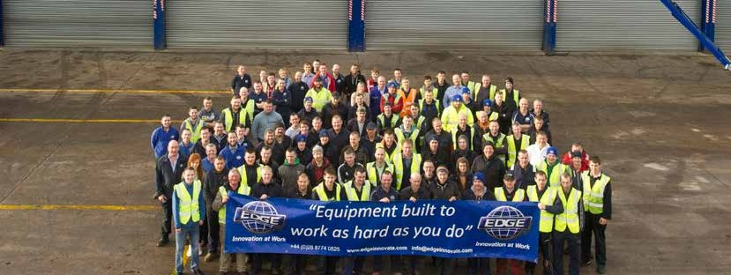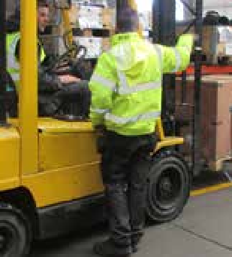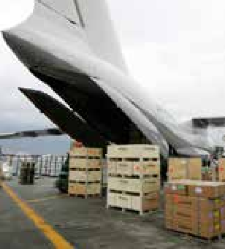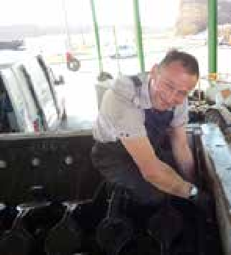Top Availability Our Aftersales Support Team are readily available for all our customer needs. We are just a call away, all day, every day.
Top Speed Express service parts available. No customer expects a long wait
for replacement
parts.
Top Priority The market rightly demands quick up- time. To make sure of this, we work tirelessly with our international couriers.
Top Satisfaction We track every despatch, keeping you informed
all the way to ensure
you are totally satisfied.

Welcome to our Comfort Zone...

SPARE
AND
wear

PARTS
+44 (0)28 8774 0525
www.edgeinnovate.com/spares aftersales@edgeinnovate.com

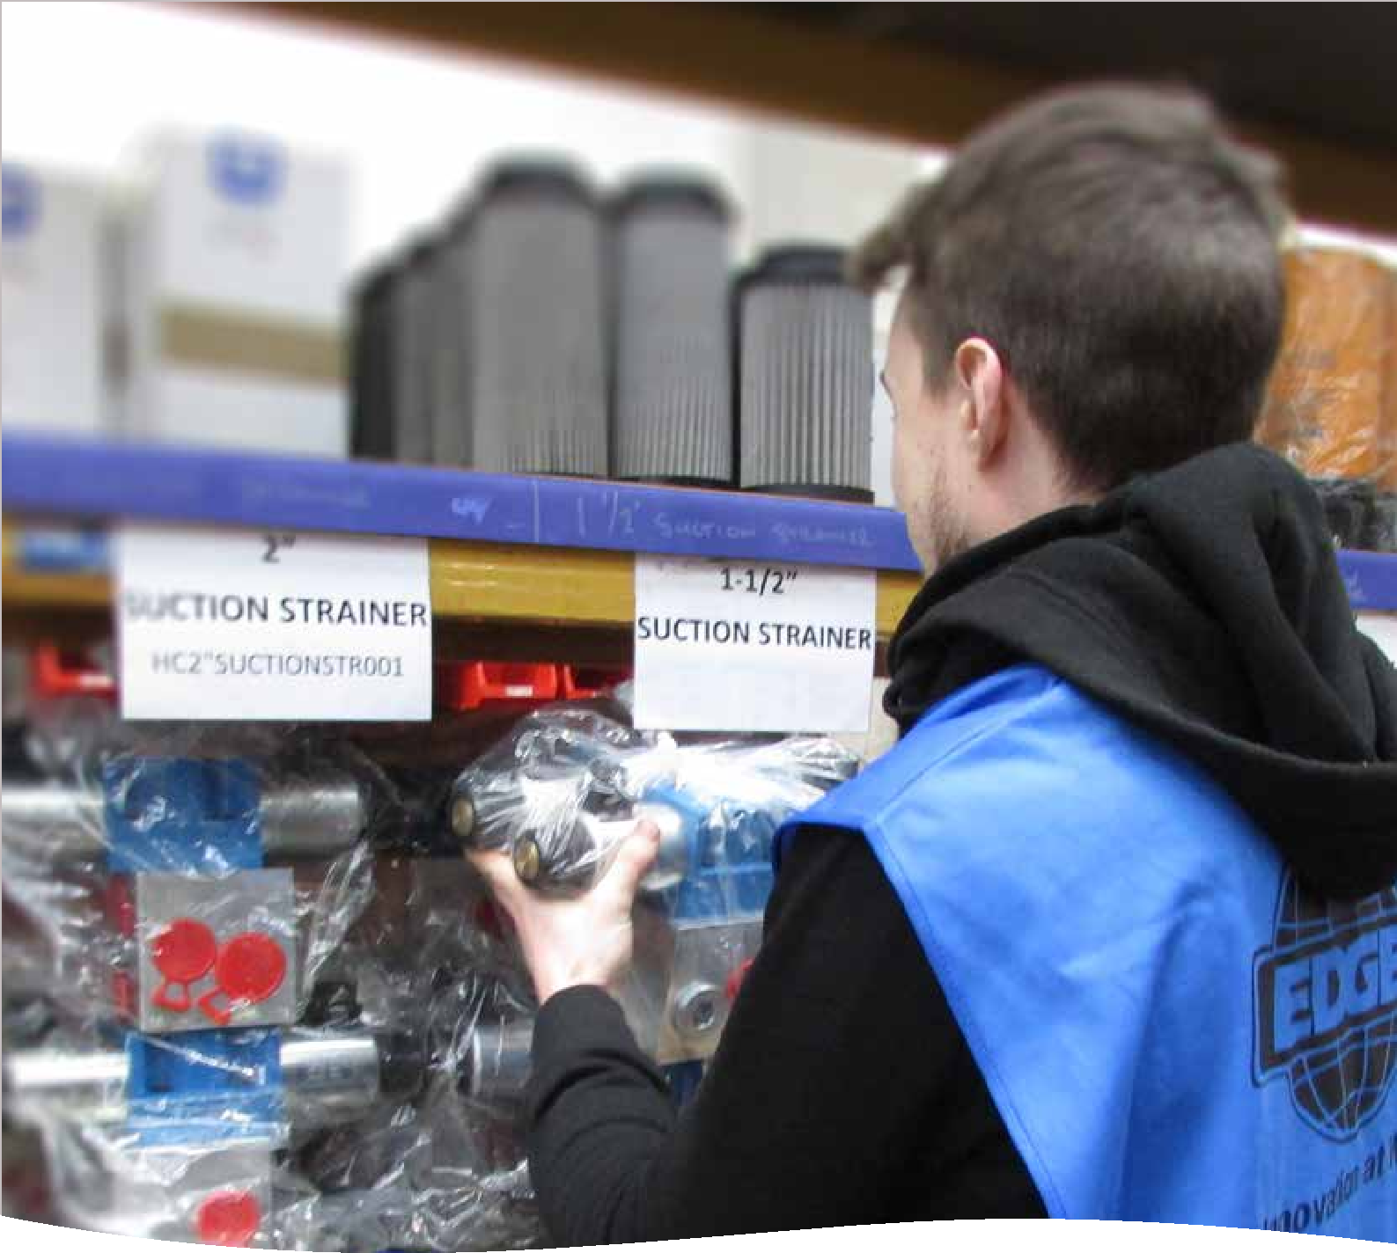
Edge Innovate’s dedicated Aftersales, Spare Parts & Technical Support team, focus entirely on helping you the customer keep your machines running. We have a stock of £10m of spares in Ireland alone, along with other spare parts hubs in strategically positioned depots. Give us a call or email us today and use our stock and experience for your advantage!

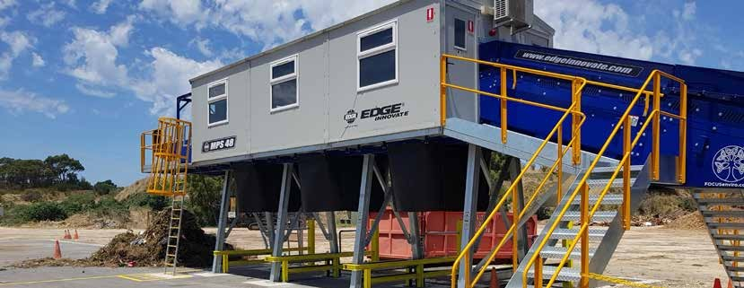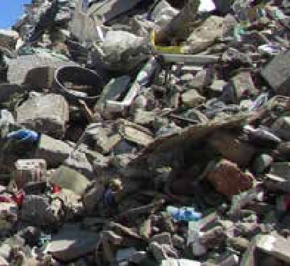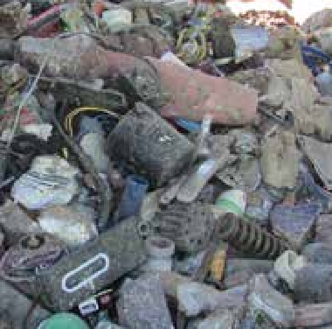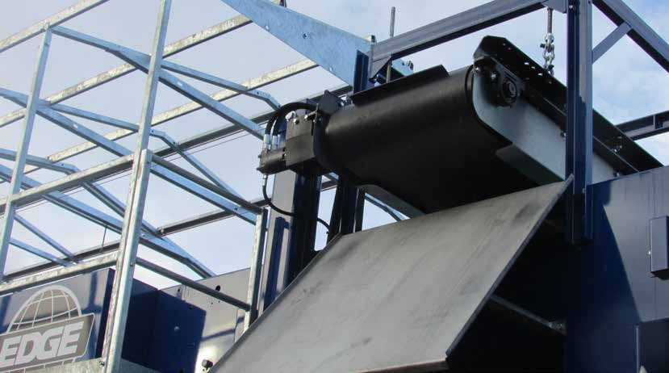MPS48 Series
MOBILE - MODULAR - PICKING STATION
+44 (0)28 8774 0525
www.edgeinnovate.com info@edgeinnovate.com

